**Prioritizing What to Work On**

**System Design Example:**

Given a data set of emails, we could construct a vector for each email. Each entry in this vector represents a word. The vector normally contains 10,000 to 50,000 entries gathered by finding the most frequently used words in our data set. If a word is to be found in the email, we would assign its respective entry a 1, else if it is not found, that entry would be a 0. Once we have all our x vectors ready, we train our algorithm and finally, we could use it to classify if an email is a spam or not.

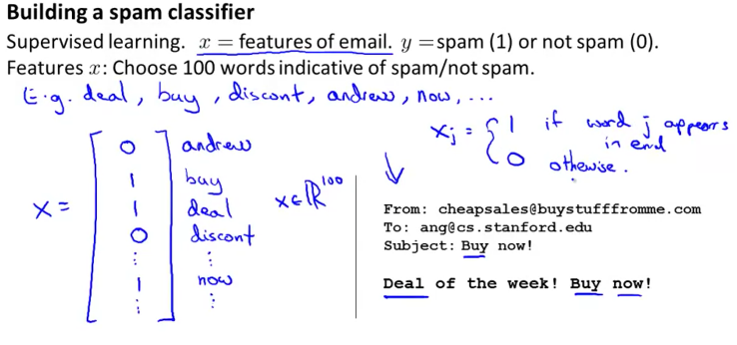

So how could you spend your time to improve the accuracy of this classifier?

* Collect lots of data (for example "honeypot" project but doesn't always work)
* Develop sophisticated features (for example: using email header data in spam emails)
* Develop algorithms to process your input in different ways (recognizing misspellings in spam).

It is difficult to tell which of the options will be most helpful.